**MINI PROJECT**

**DATA ENGINEERING**

**DSLS 2023**

Name :

Ni Putu Ananda Vika Jantika

Date :

January, 2023

**Bagian 2a Transform : Intermediate Queries**

1. Tulis query untuk mendapatkan jumlah customer tiap bulan yang melakukan order pada tahun 1997

SELECT

COUNT(Customers.CustomerID) AS Jumlah_Customer,

MONTH(Orders.OrderDate) AS Bulan

FROM

Orders

LEFT JOIN Customers ON Orders.CustomerID=Customers.CustomerID

WHERE

YEAR(Orders.OrderDate)='1997'

GROUP BY

MONTH(Orders.OrderDate)

Hasil :

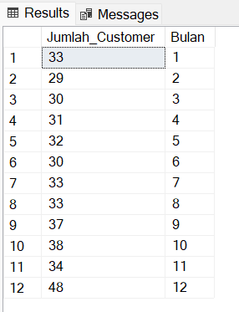

1. Tulis query untuk mendapatkan nama employee yang termasuk Sales Representative

SELECT

CONCAT(FirstName,' ',LastName) AS EmployeeName,

Title

FROM

Employees

WHERE

Title='Sales Representative'

Hasil :

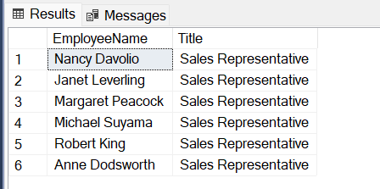

1. Tulis query untuk mendapatkan top 5 nama produk yang quantitynya paling banyak diorder pada bulan Januari 1997

SELECT

TOP 5

Products.ProductName,

[Order Details].Quantity

FROM

[Order Details]

LEFT JOIN Products ON [Order Details].ProductID = Products.ProductID

LEFT JOIN Orders ON [Order Details].OrderID = Orders.OrderID

WHERE

Orders.OrderDate BETWEEN '1997-01-01' AND '1997-01-31'

ORDER BY

Quantity DESC

Hasil :

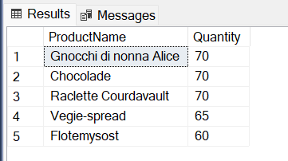

1. Tulis query untuk mendapatkan nama company yang melakukan order Chai pada bulan Juni 1997

SELECT

Orders.OrderID,

Products.ProductName,

Customers.CompanyName

FROM

Orders

LEFT JOIN Customers ON Orders.CustomerID=Customers.CustomerID

LEFT JOIN [Order Details] on [Order Details].OrderID = Orders.OrderID

LEFT JOIN Products on [Order Details].ProductID = Products.ProductID

WHERE

YEAR(Orders.OrderDate)='1997' AND MONTH(Orders.OrderDate)='06' AND Products.ProductName='Chai'

Hasil :

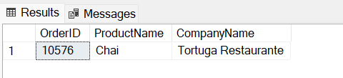

1. Tulis query untuk mendapatkan jumlah OrderID yang pernah melakukan pembelian (unit_price dikali quantity) <=100, 100<x<=250, 250<x<=500, dan >500

SELECT

CASE

WHEN Products.UnitPrice*[Order Details].Quantity <=100 THEN 'Below $100'

WHEN Products.UnitPrice*[Order Details].Quantity > 100 AND Products.UnitPrice*[Order Details].Quantity <= 250 THEN '$100 - $250'

WHEN Products.UnitPrice*[Order Details].Quantity > 250 AND Products.UnitPrice*[Order Details].Quantity <= 500 THEN '$250 - $500'

WHEN Products.UnitPrice*[Order Details].Quantity > 500 THEN 'Over $500'

END AS Price_Range,

COUNT ([Order Details].OrderID) AS Jumlah_OrderID

FROM

[Order Details]

LEFT JOIN Products on [Order Details].ProductID = Products.ProductID

GROUP BY

CASE

WHEN Products.UnitPrice*[Order Details].Quantity <=100 THEN 'Below $100'

WHEN Products.UnitPrice*[Order Details].Quantity > 100 AND Products.UnitPrice*[Order Details].Quantity <= 250 THEN '$100 - $250'

WHEN Products.UnitPrice*[Order Details].Quantity > 250 AND Products.UnitPrice*[Order Details].Quantity <= 500 THEN '$250 - $500'

WHEN Products.UnitPrice*[Order Details].Quantity > 500 THEN 'Over $500'

END

ORDER BY

Price_Range

Hasil :

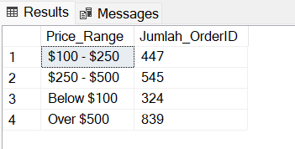

1. Tulis query untuk mendapatkan Company name pada tabel customer yang melakukan pembelian di atas 500 pada tahun 1997

SELECT

Customers.CompanyName,

YEAR(Orders.OrderDate) AS Tahun,

Products.UnitPrice*[Order Details].Quantity as Pembelian

FROM

Orders

LEFT JOIN [Order Details] ON Orders.OrderID = [Order Details].OrderID

LEFT JOIN Products ON [Order Details].ProductID=Products.ProductID

LEFT JOIN Customers ON Orders.CustomerID = Customers.CustomerID

WHERE

YEAR(Orders.OrderDate)='1997' AND [Order Details].UnitPrice*Quantity>500

Hasil :

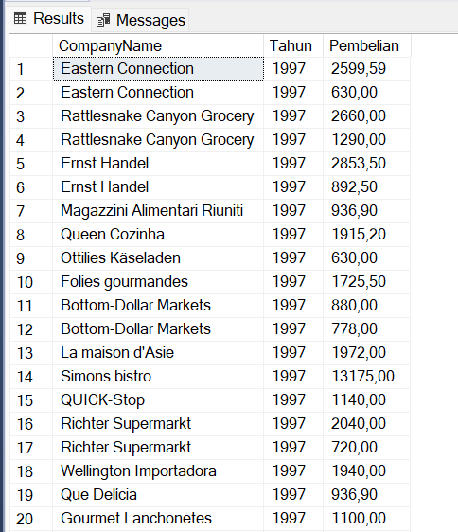

1. Tulis query untuk mendapatkan nama produk yang merupakan Top 5 sales tertinggi tiap bulan di tahun 1997
2. Buatlah view untuk melihat Order Details yang berisi OrderID, ProductID, ProductName, UnitPrice, Quantity, Discount, Harga setelah diskon

CREATE VIEW [NewOrderDetails] AS

SELECT

[Order Details].OrderID,

[Order Details].ProductID,

Products.ProductName,

Products.UnitPrice,

[Order Details].Quantity,

[Order Details].Discount,

[Order Details].UnitPrice AS UnitPriceAfterDisc

FROM

[Order Details]

LEFT JOIN Products ON [Order Details].ProductID = Products.ProductID*/

Hasil :

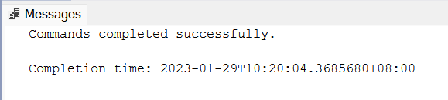

--Check View

SELECT * FROM [NewOrderDetails]

Hasil :

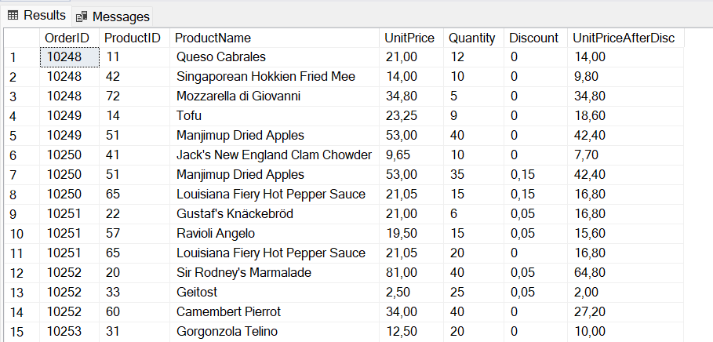

1. Buatlah procedure Invoice untuk memanggil CustomerID, CustomerName/company name, OrderID, OrderDate, RequiredDate, ShippedDate jika terdapat inputan CustomerID tertentu

CREATE PROCEDURE INVOICE0 @CUSTOMERID NVARCHAR(40)

AS

SELECT

Customers.CustomerID, Customers.CompanyName,

Orders.OrderID, Orders.OrderDate,

Orders.RequiredDate, Orders.ShippedDate

FROM

Orders

LEFT JOIN Customers ON Orders.CustomerID = Customers.CustomerID

WHERE

Customers.CustomerID = @CUSTOMERID

GO

--Execute dengan input CustomerID ALFKI

EXEC INVOICE0 @CUSTOMERID = 'ALFKI'

Hasil :

